NAVTAC AI Training Program

Course Title: Machine Learning & Data Science

Instructor: Gulshan Yasmeen

Institution: NAVTAC AI Training Program

Project Type: Mid-Term Project

Student Name: Sadaf Khan

Title: AI Assistant Usage in Student Life: A Machine Learning Analysis

Problem Statement:
With the rapid integration of AI-powered assistants in education, understanding how students use these tools has become critical. Students increasingly rely on AI systems (like ChatGPT or Google Bard) for assignments, idea generation, and concept clarification. However, the extent to which AI use impacts learning outcomes, satisfaction, and future adoption remains underexplored.
This project investigates patterns in AI assistant usage among students of different academic levels and disciplines. The goal is to analyze behavioral trends and build a predictive model to determine whether a student is likely to use AI again based on their interaction patterns.

Objectives:
- To analyze AI usage behavior among students of different levels and fields.
- To explore relationships between session length, satisfaction, and learning outcomes.
- To detect factors influencing whether students plan to use AI assistants again.
- To develop and evaluate machine learning models predicting student re-use intentions.

Dataset Description:
- Source: Kaggle dataset — AI Assistant Usage in Student Life (Synthetic) by ayeshasal89.
- Size: ~10,000 records.
- Format: CSV file.
- Key Features:
  - StudentLevel, Discipline, TaskType, AI_AssistanceLevel, SatisfactionRating, SessionLengthMin, TotalPrompts, UsedAgain, FinalOutcome.
- Target Variable: UsedAgain (whether a student would use AI again).

Data Mining and Exploration

Exploratory Steps:
- Loaded and inspected the dataset using pandas.
- Checked for null values, duplicates, and overall structure using .info() and .describe().
- Dropped irrelevant columns (SessionID, SessionDate) for model simplicity.

Findings:
- No significant missing values.
- Numerical columns: SessionLengthMin, TotalPrompts, AI_AssistanceLevel, SatisfactionRating.
- Categorical columns: StudentLevel, Discipline, TaskType, FinalOutcome, UsedAgain.

Initial Observations:
- Most users were undergraduate students.
- Common disciplines included Computer Science, Engineering, and Arts.
- The majority of students expressed positive satisfaction ratings.
Data Preprocessing

Steps Performed:
- Missing Value Handling: No major missing data detected.
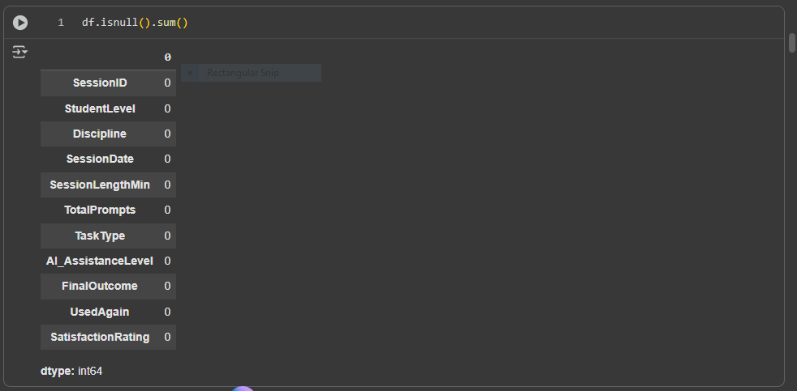
- Outlier Detection & Removal: Applied the IQR method on numerical columns.
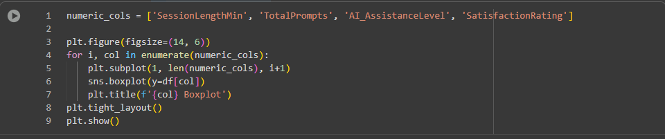
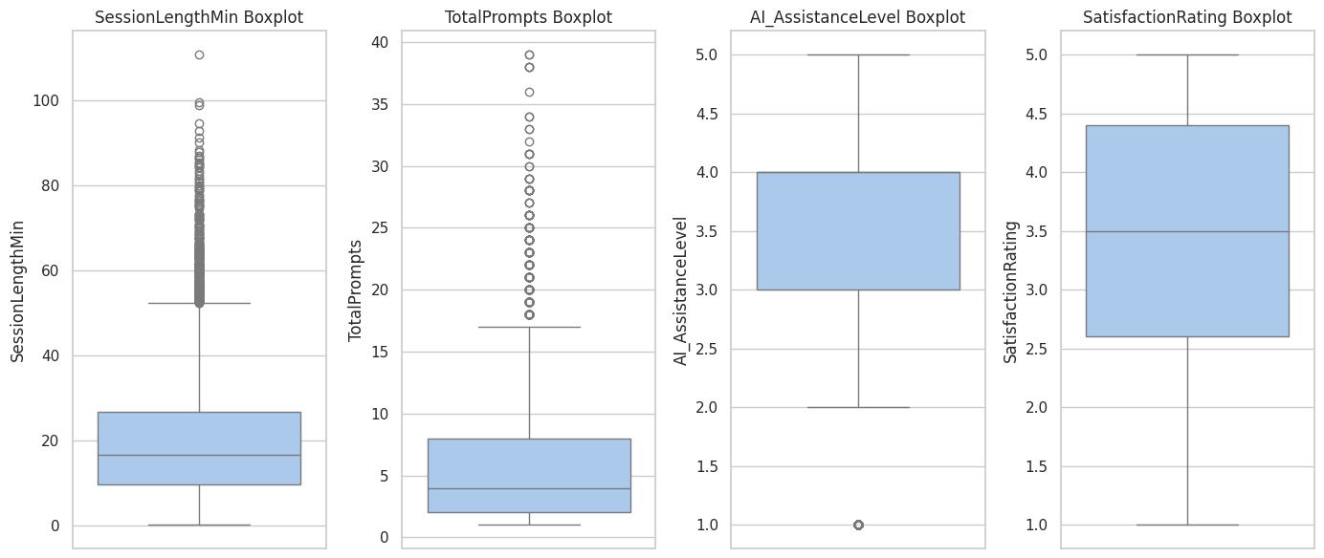
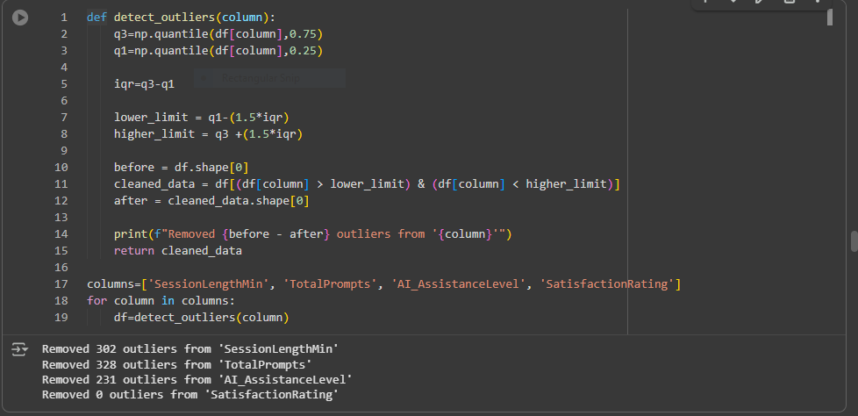
- Encoding Categorical Variables: Used One-Hot Encoding (pd.get_dummies()).
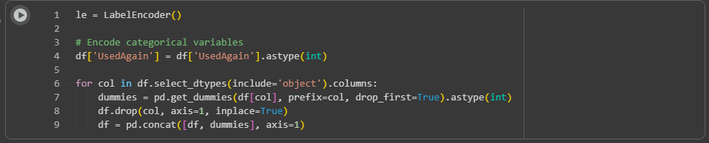

- Scaling Numerical Features: Applied StandardScaler to normalize data.
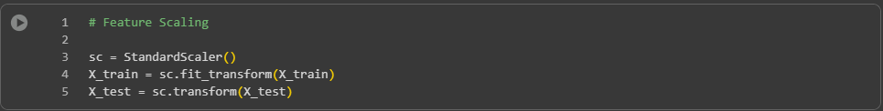
- Train-Test Split:
  - Train: 80%
  - Test: 20%
  - Stratified split based on UsedAgain.
Data Visualization

Visual Insights:
Visualizations were created using Seaborn and Matplotlib (e.g., boxplots, scatterplots, bar charts, and heatmaps).
- Distribution of Student Levels: Most sessions came from undergraduates.

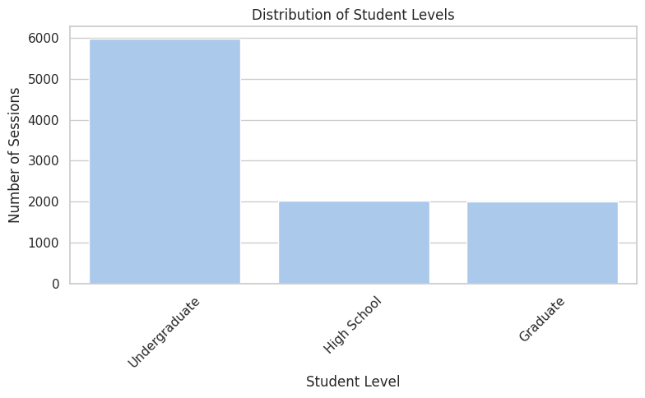

- Sessions by Discipline: Computer Science had the highest interaction rate.

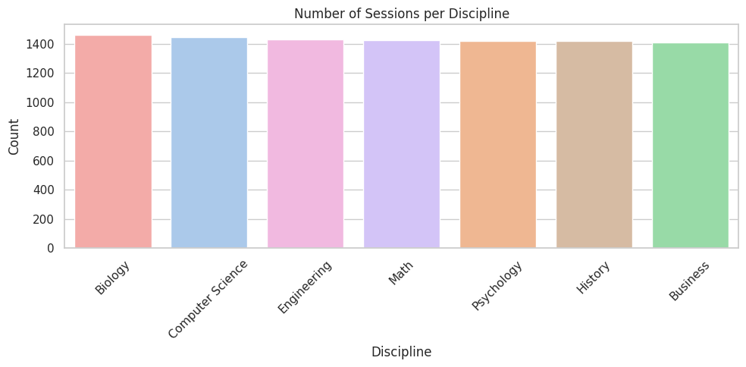
- AI Assistance vs Final Outcome: High AI assistance correlated with higher success rates.
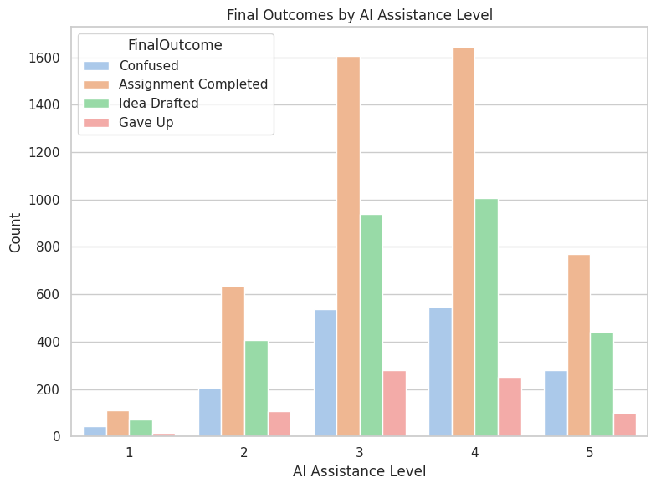

- Satisfaction by Task Type: Research-related tasks had higher satisfaction scores.
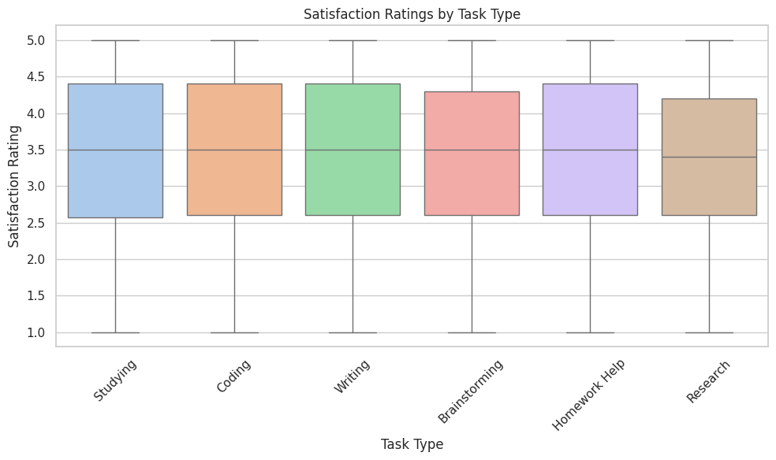

- Session Length vs Total Prompts: Longer sessions often involved more prompts.
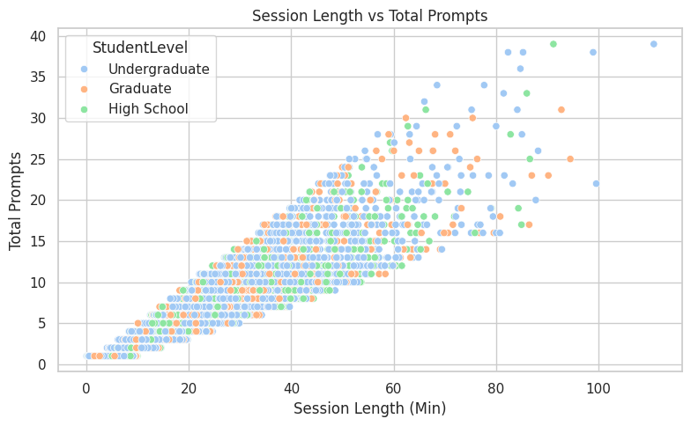

- Used Again Decision: Majority of students expressed willingness to reuse AI tools.
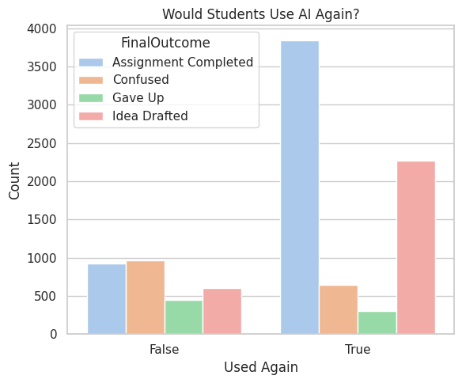

- Correlation Heatmap: Showed strong positive correlation between SessionLengthMin, TotalPrompts, and satisfaction.
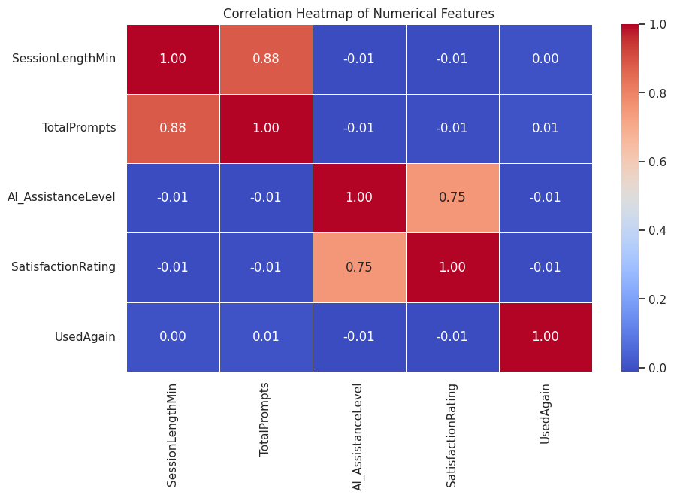

Model Development

Supervised Learning Algorithms Used:
Model | Type | Description
Logistic Regression | Classification | Predicts binary outcomes (UsedAgain) based on input features.
Random Forest | Ensemble Classification | Uses multiple decision trees to improve predictive accuracy.
Decision Tree | Classification | Simple interpretable model based on feature splits.

Reason for Selection:
- Logistic Regression provides interpretability and performs well on linear relationships.
- Random Forest captures non-linear patterns and interactions between variables.
- Decision Tree offers an easily explainable structure for educational insights.

Model Evaluation

Performance Results:
Model | Accuracy | Mean Squared Error | Confusion Matrix
Logistic Regression | 0.74 | 0.26 | [[243, 294], [175, 1116]]
Random Forest | 0.73 | 0.27 | [[186, 351], [149, 1142]]
Decision Tree | 0.63 | 0.37 | [[210, 327], [353, 938]]

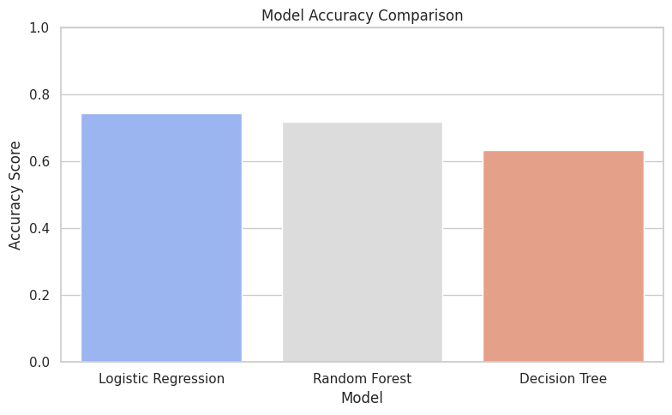
Best Performing Model:
Logistic Regression achieved 74% accuracy and the best balance between precision and recall.
Evaluation Metrics Used:
- Accuracy: Overall correct predictions.
- Precision, Recall, F1-Score: For detailed performance per class.
- Mean Squared Error: To assess prediction quality.
- Confusion Matrix: Visualized classification performance.

Conclusion and Recommendations

Key Insights:
- Undergraduate students are the most active AI users.
- Longer sessions and higher AI assistance lead to more positive outcomes.
- Satisfaction rating is a strong predictor of whether students plan to use AI again.
- The Logistic Regression model reliably predicts AI re-usage intention.

Limitations:
- The dataset is synthetic, limiting real-world generalization.
- No unsupervised learning model (e.g., clustering) was included due to time constraints.
- External factors like internet connectivity or study pressure were not captured.

Recommendations:
- Apply K-Means clustering to group students by behavior patterns.
- Collect real-world data from multiple institutions for better validation.
- Explore Neural Networks or XGBoost for improved accuracy.
- Incorporate time-based trend analysis for longitudinal insights.

